**CSE462**

**HW4**

**REPORT**

**1801042631**

In this assignment, all operations are done in a script file named 'World.cs'.

First, a unity 3D project is created. Then an empty object is created. Then put 'World.cs' in the empty object and run it.

World.cs content:

metin içeren bir resim

Açıklama otomatik olarak oluşturuldu

In the first part of the project, definitions were made. The list of objects, the list of lights, the list of black holes, and the necessary materials are defined. 4 objects, 3 lights and 1 black hole were used. Preparations were made for the ray casting operation.

metin içeren bir resim

Açıklama otomatik olarak oluşturuldu

In the start function, objects and lights are created in a loop. The **'MeshCollider'** component is used so that the rays can hit the objects.

metin içeren bir resim

Açıklama otomatik olarak oluşturuldu

Again, a black hole was created within the start function and the **'SphereCollider'** component was used to affect the light from the black hole.

Camera settings have been made.

metin içeren bir resim

Açıklama otomatik olarak oluşturuldu

metin içeren bir resim

Açıklama otomatik olarak oluşturuldu

Again, within the start function, 'LineRenderer' adjustments have been made to be used in Ray Casting operation. In addition, adjustments have been made to save the result as a png file.

metin içeren bir resim

Açıklama otomatik olarak oluşturuldu

Ray Casting operation is applied within the Update function. Two different cases of whether the rays hit an object or not were examined. By using the "Debug.drawline" method, the direction of the rays is drawn with a green line.

metin içeren bir resim

Açıklama otomatik olarak oluşturuldu

CreateObject method. Thanks to this method, objects were created and materials were added.

metin içeren bir resim

Açıklama otomatik olarak oluşturuldu

CreateBlackHole method. This method create blackhole

metin içeren bir resim

Açıklama otomatik olarak oluşturuldu

BlackHole class. Thanks to this class, black holes have been identified. The CreateBlackHole method made use of this class.

metin, elektronik eşyalar, vitrin, ekran görüntüsü içeren bir resim

Açıklama otomatik olarak oluşturuldu

This is the world. There are 4 pink colored objects in the world. There is a black hole and 3 lights. The beam sent by Ray Casting is shown in green. The beam was cut by the black hole.

metin, ekran, iç mekan, ekran görüntüsü içeren bir resim

Açıklama otomatik olarak oluşturuldu

This is the camera screen.

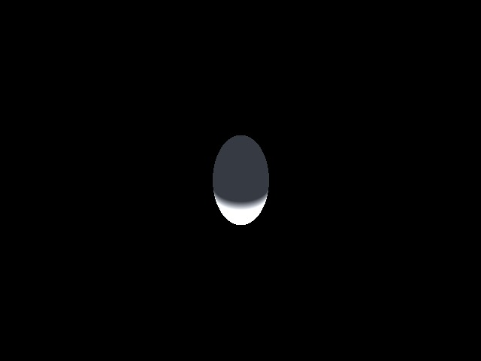

Here is an example output png file. The image of the object is shadowed because of the black hole.